- Program ID : VP001MA1

- Display Layout
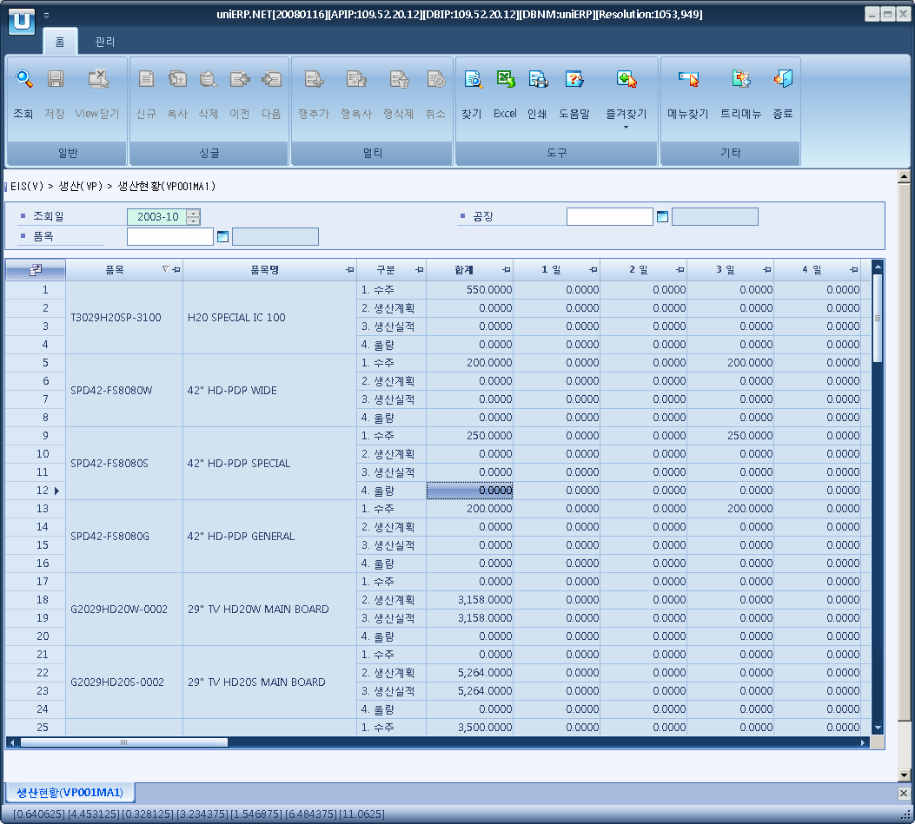

- Event flow
- Click Query button
- OnFncQuery -> DbQuery -> DataChange
- Display Unit combo change
- uniCombo1_ValueChanged -> DataChange

- SQL Statements
- Auto P/O rate
SELECT CASE WHEN b.item_cd IS NULL THEN 'ZZZZZZZZ' ELSE b.item_cd END AS item_cd,
CASE WHEN b.item_cd IS NULL THEN '합계' ELSE MAX(b.item_nm) END AS item_nm, c.flag,
ISNULL(SUM(CASE WHEN a.flag = c.flag THEN a.qty ELSE 0 END), 0) AS sum_qty,
ISNULL(SUM(CASE WHEN DAY(a.dlvy_dt) = 1 AND a.flag = c.flag THEN a.qty ELSE 0 END), 0) AS qty01,
ISNULL(SUM(CASE WHEN DAY(a.dlvy_dt) = 2 AND a.flag = c.flag THEN a.qty ELSE 0 END), 0) AS qty02,
ISNULL(SUM(CASE WHEN DAY(a.dlvy_dt) = 3 AND a.flag = c.flag THEN a.qty ELSE 0 END), 0) AS qty03,
ISNULL(SUM(CASE WHEN DAY(a.dlvy_dt) = 4 AND a.flag = c.flag THEN a.qty ELSE 0 END), 0) AS qty04,
ISNULL(SUM(CASE WHEN DAY(a.dlvy_dt) = 5 AND a.flag = c.flag THEN a.qty ELSE 0 END), 0) AS qty05,
ISNULL(SUM(CASE WHEN DAY(a.dlvy_dt) = 6 AND a.flag = c.flag THEN a.qty ELSE 0 END), 0) AS qty06,
ISNULL(SUM(CASE WHEN DAY(a.dlvy_dt) = 7 AND a.flag = c.flag THEN a.qty ELSE 0 END), 0) AS qty07,
ISNULL(SUM(CASE WHEN DAY(a.dlvy_dt) = 8 AND a.flag = c.flag THEN a.qty ELSE 0 END), 0) AS qty08,
ISNULL(SUM(CASE WHEN DAY(a.dlvy_dt) = 9 AND a.flag = c.flag THEN a.qty ELSE 0 END), 0) AS qty09,
ISNULL(SUM(CASE WHEN DAY(a.dlvy_dt) = 10 AND a.flag = c.flag THEN a.qty ELSE 0 END), 0) AS qty10,
ISNULL(SUM(CASE WHEN DAY(a.dlvy_dt) = 11 AND a.flag = c.flag THEN a.qty ELSE 0 END), 0) AS qty11,
ISNULL(SUM(CASE WHEN DAY(a.dlvy_dt) = 12 AND a.flag = c.flag THEN a.qty ELSE 0 END), 0) AS qty12,
ISNULL(SUM(CASE WHEN DAY(a.dlvy_dt) = 13 AND a.flag = c.flag THEN a.qty ELSE 0 END), 0) AS qty13,
ISNULL(SUM(CASE WHEN DAY(a.dlvy_dt) = 14 AND a.flag = c.flag THEN a.qty ELSE 0 END), 0) AS qty14,
ISNULL(SUM(CASE WHEN DAY(a.dlvy_dt) = 15 AND a.flag = c.flag THEN a.qty ELSE 0 END), 0) AS qty15,
ISNULL(SUM(CASE WHEN DAY(a.dlvy_dt) = 16 AND a.flag = c.flag THEN a.qty ELSE 0 END), 0) AS qty16,
ISNULL(SUM(CASE WHEN DAY(a.dlvy_dt) = 17 AND a.flag = c.flag THEN a.qty ELSE 0 END), 0) AS qty17,
ISNULL(SUM(CASE WHEN DAY(a.dlvy_dt) = 18 AND a.flag = c.flag THEN a.qty ELSE 0 END), 0) AS qty18,
ISNULL(SUM(CASE WHEN DAY(a.dlvy_dt) = 19 AND a.flag = c.flag THEN a.qty ELSE 0 END), 0) AS qty19,
ISNULL(SUM(CASE WHEN DAY(a.dlvy_dt) = 20 AND a.flag = c.flag THEN a.qty ELSE 0 END), 0) AS qty20,
ISNULL(SUM(CASE WHEN DAY(a.dlvy_dt) = 21 AND a.flag = c.flag THEN a.qty ELSE 0 END), 0) AS qty21,
ISNULL(SUM(CASE WHEN DAY(a.dlvy_dt) = 22 AND a.flag = c.flag THEN a.qty ELSE 0 END), 0) AS qty22,
ISNULL(SUM(CASE WHEN DAY(a.dlvy_dt) = 23 AND a.flag = c.flag THEN a.qty ELSE 0 END), 0) AS qty23,
ISNULL(SUM(CASE WHEN DAY(a.dlvy_dt) = 24 AND a.flag = c.flag THEN a.qty ELSE 0 END), 0) AS qty24,
ISNULL(SUM(CASE WHEN DAY(a.dlvy_dt) = 25 AND a.flag = c.flag THEN a.qty ELSE 0 END), 0) AS qty25,
ISNULL(SUM(CASE WHEN DAY(a.dlvy_dt) = 26 AND a.flag = c.flag THEN a.qty ELSE 0 END), 0) AS qty26,
ISNULL(SUM(CASE WHEN DAY(a.dlvy_dt) = 27 AND a.flag = c.flag THEN a.qty ELSE 0 END), 0) AS qty27,
ISNULL(SUM(CASE WHEN DAY(a.dlvy_dt) = 28 AND a.flag = c.flag THEN a.qty ELSE 0 END), 0) AS qty28,
ISNULL(SUM(CASE WHEN DAY(a.dlvy_dt) = 29 AND a.flag = c.flag THEN a.qty ELSE 0 END), 0) AS qty29,
ISNULL(SUM(CASE WHEN DAY(a.dlvy_dt) = 30 AND a.flag = c.flag THEN a.qty ELSE 0 END), 0) AS qty30,
ISNULL(SUM(CASE WHEN DAY(a.dlvy_dt) = 31 AND a.flag = c.flag THEN a.qty ELSE 0 END), 0) AS qty31
FROM (SELECT a.plant_cd, a.item_cd, '1. 수주' AS flag, a.dlvy_dt, -- 수주수량(납기일 기준)
SUM(CASE WHEN DAY(a.dlvy_dt) = 1 AND b.ret_item_flag = 'Y' THEN -a.so_base_qty ELSE a.so_base_qty END) AS qty
FROM s_so_dtl a
INNER JOIN s_so_hdr b
ON b.so_no = a.so_no
AND b.cfm_flag = 'y'
WHERE a.dlvy_dt BETWEEN @strYyyyMm + '01'
AND DATEADD(DAY, -1, DATEADD(MONTH, 1, @strYyyyMm + '01'))
AND a.plant_cd LIKE @strPlantCd
AND a.item_cd >= @strItemCd
GROUP BY a.plant_cd, a.item_cd, a.dlvy_dt
UNION ALL -- 생산계획수량(완성일 기준)
SELECT c.plant_cd, c.item_cd, '2. 생산계획' AS flag, c.plan_compt_dt, sum(c.order_qty_in_base_unit)
FROM p_production_order_header c
WHERE c.plan_compt_dt BETWEEN @strYyyyMm + '01'
AND DATEADD(DAY, -1, DATEADD(MONTH, 1, @strYyyyMm + '01'))
AND c.plant_cd LIKE @strPlantCd
AND c.item_cd >= @strItemCd
GROUP BY c.plant_cd, c.item_cd, c.plan_compt_dt

UNION ALL -- 생산수량, 불량수량(생산불량+품질불량)
SELECT c.plant_cd, c.item_cd, '3. 생산실적' AS flag, e.report_dt, SUM(e.prod_qty_in_base_unit)
FROM p_production_results e
INNER JOIN p_production_order_header c
ON e.prodt_order_no = c.prodt_order_no
AND c.item_cd >= @strItemCd
INNER JOIN p_production_order_detail d
ON e.prodt_order_no = d.prodt_order_no
AND e.opr_no = d.opr_no
WHERE e.report_dt BETWEEN @strYyyyMm + '01'
AND DATEADD(DAY, -1, DATEADD(MONTH, 1, @strYyyyMm + '01'))
AND e.del_flg = 'N'
AND d.rout_order IN ('S','L')
AND e.plant_cd LIKE @strPlantCd
GROUP BY c.plant_cd, c.item_cd, e.report_dt
UNION ALL -- 생산수량, 불량수량(생산불량+품질불량)
SELECT c.plant_cd, c.item_cd, '4. 불량' AS flag, e.report_dt,
SUM(e.insp_bad_qty_in_base_unit + CASE WHEN e.report_type = 'b' THEN e.prod_qty_in_base_unit ELSE 0 END)
FROM p_production_results e
INNER JOIN p_production_order_header c
ON c.prodt_order_no = e.prodt_order_no
AND c.item_cd >= @strItemCd
INNER JOIN p_production_order_detail d
ON d.prodt_order_no = e.prodt_order_no
AND d.opr_no = e.opr_no
AND d.rout_order IN ('S','L')
WHERE e.report_dt BETWEEN @strYyyyMm + '01'
AND DATEADD(DAY, -1, DATEADD(MONTH, 1, @strYyyyMm + '01'))
AND e.del_flg = 'N'
AND e.plant_cd LIKE @strPlantCd
GROUP BY c.plant_cd, c.item_cd, e.report_dt) a
INNER JOIN b_item b
ON b.item_cd = a.item_cd
CROSS JOIN (SELECT '1. 수주' AS flag UNION ALL SELECT '2. 생산계획' UNION ALL SELECT '3. 생산실적'
UNION ALL SELECT '4. 불량') c
GROUP BY c.flag, b.item_cd WITH ROLLUP
HAVING c.flag IS NOT NULL
ORDER BY b.item_cd, b.item_nm, c.flag

